

Palm Sunday

-Hope

OLOL Chapter

Weekly Newsletter

Holy week has begun. During Lent we worked on and completed the virtue of Temperance. With Palm Sunday, we begin a new virtue. The virtue of HOPE. We read on page 94 of our Fidelis book that, Hope roots us in the attainment of heaven. Hope shows us that trusting in God’s promises means we trust him even when we suffer. ***Therefore…the hopeful woman trusts God when she suffers.***

**Invitation:** Your Invitation this week is to attend, with great devotion and attention, some of this week’s Liturgy. Be sure to contemplate the complete abandonment of Jesus to the Father’s will, even through the suffering of the cross. Pray to Our Lady and ask her to help you console Jesus by uniting your heart to His in His suffering the way she did.

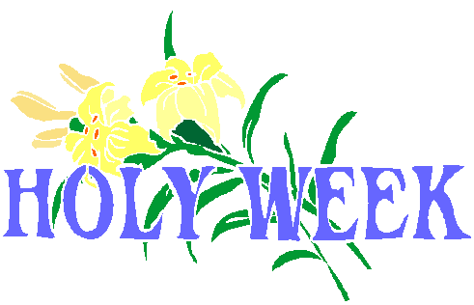

[**This Photo**](http://free-illustrations.gatag.net/2013/12/23/180000.html) **by Unknown Author is licensed under** [**CC BY**](https://creativecommons.org/licenses/by/3.0/)

*If either is impossible, devoting this time to prayer at home fulfills the Invitation.

The Holy Tridiuum at Our Lady of the Lake:

**Holy Thursday** – 7:00 P.M.

Evening Mass of the Lord’s Supper

**Good Friday** – 1:00 P.M.

Live Stations of the Cross in Spanish

**Good Friday** - 7:00 P.M.

Celebration of the Lord’s Passion

**Easter Vigil Mass** – 7:30 P.M.

**Easter Sunday Mass** – 8:30 & 11:00AM, 6:00PM

**Upcoming Calendar**:

Made in Office 2007 for office2007.com

Made in Office 2007 for office2007.com

Monday, March 26, 2018 – **NO MEETING** Spring Break

Monday, April 2 – dinner + meeting Fidelis Ranch Parent Meeting - teen room - 8:00PM

Monday, April 9 – dinner + meeting

Monday, April 16 – dinner + meeting

Monday, April 23 – dinner + meeting

Monday, April 30 – dinner + meeting

Dinner provided by

4/2: Jennifer Clemens & Hilda Robles

4/9: Kerry Hartley & Katrina Henderson

4/16: Becky Knight & Tara Ludwig

4/23: Lynne Meyer-Reynolds & Nyka Moore

4/30: Lori Reeves & Angie Reynolds

**May 7th - Fidelis Honor Ceremony & Potluck**



[This Photo](http://jessescrossroadscafe.blogspot.com/2014/11/gold-daily-and-silver-weekly-charts_28.html) by Unknown Author is licensed under [CC BY-NC-ND](https://creativecommons.org/licenses/by-nc-nd/3.0/)

|  |
| --- |
|  |

|  |  |  |  |  |  |  |  |  |  |  |  |  |  |  |  |  |  |  |
| --- | --- | --- | --- | --- | --- | --- | --- | --- | --- | --- | --- | --- | --- | --- | --- | --- | --- | --- |
| |  |  | | --- | --- | | |  | | --- | |  | |  |  | | --- | |  |  |  | | --- | |  | | |  | | --- | |  | |  |  | | --- | |  | |  |  |  | | --- | |  | | |  |  |  | | --- | --- | --- | | |  |  | | --- | --- | | |  | | --- | |  | | | |  |  | | --- | |  | |  |  |  | | --- | |  | | |  | | --- | |  | | |

